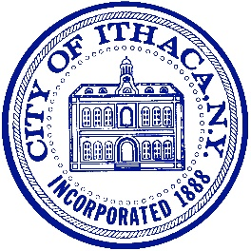
CITY OF ITHACA MURAL STREET ART PROGRAM
Proposal Application

Applicant / Contact Name(s):
_____________________________________________________________________________
Organization / Institution (if applicable): ____________________________________________
Address: ______________________________________________________________________
Phone: Email: __________________________________________________________________
Website: ______________________________________________________________________
Project Title: ___________________________________________________________________
Checklist of items to enclose with application:
● Sketch of proposed work
● Description of proposed work
● List of materials to be used and equipment needed for the project
● Budget estimate for project as proposed
● Description of community involvement (if applicable)
● Artist resume or description of prior art experience
● Images featuring at least three previous pieces (of similar scale if possible)
Applicant Signature: ________________________________________ Date: ______________
Please submit this form and application materials to:

City of Ithaca Public Art Commission
Department of Planning and Development
City Hall, 3rd Floor
108 East Green Street
Ithaca, NY 14850

